# 1. (additional query) student fullname who enrolled in a specific subject

SELECT s.fullName, su.subjectName

FROM student s

INNER JOIN subjectEnrolment se

ON s.studentID=se.studentID

INNER JOIN subject su

ON se.subjectID=su.subjectName;

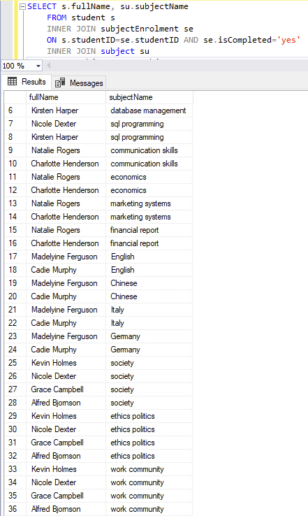

# 2. (additional query) course name and each subjects

SELECT co.courseName, s.subjectName

FROM course co

INNER JOIN courseSubject cs

ON co.courseID=cs.courseID

INNER JOIN subject s

ON cs.subjectID=s.subjectID;

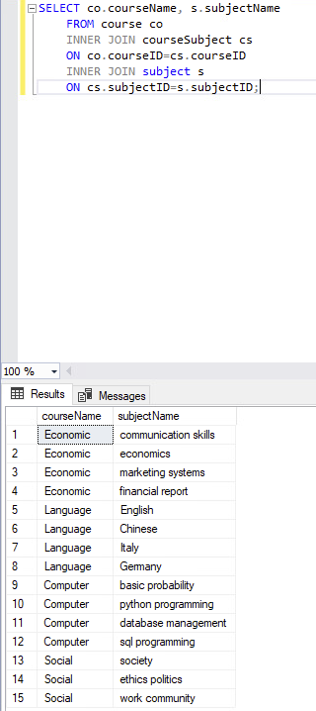

# 3. (additional query) number of students who in each subject

## it is limited to show the courseName in the result table because of the aggregate function showing number of student.

## Because of the limitation, the specific course which student enrolled can only be seen by the query,

## other option to access the enrolled subject can be done by using subject enrolment way (ignore specific course-which this happens in WSU subject enrolment).

## this task can be done in two ways (the queries below give the same result).

SELECT cs.subjectID, COUNT(g.num) AS numberOfStudent

FROM (SELECT ce.studentID AS num, co.courseID

FROM courseEnrolment ce

INNER JOIN course co

ON co.courseID=ce.courseID) AS g, courseSubject cs

WHERE g.courseID=cs.courseID

GROUP BY cs.subjectID;

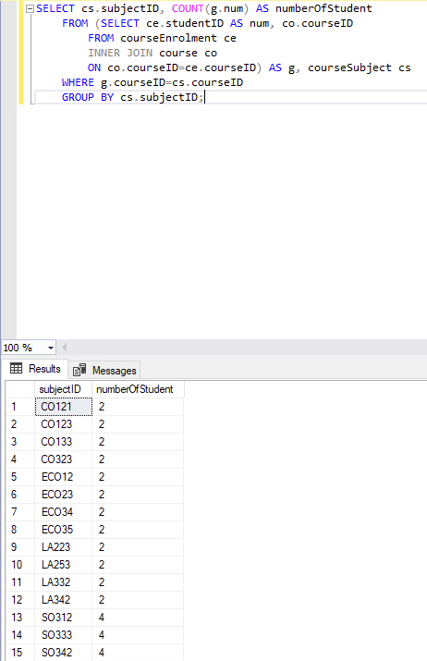

SELECT cs.subjectID, COUNT(ce.studentID) AS numberOfStudent

FROM courseEnrolment ce

INNER JOIN course c

ON c.courseID=ce.courseID

INNER JOIN courseSubject cs

ON cs.courseID=c.courseID

GROUP BY cs.subjectID;

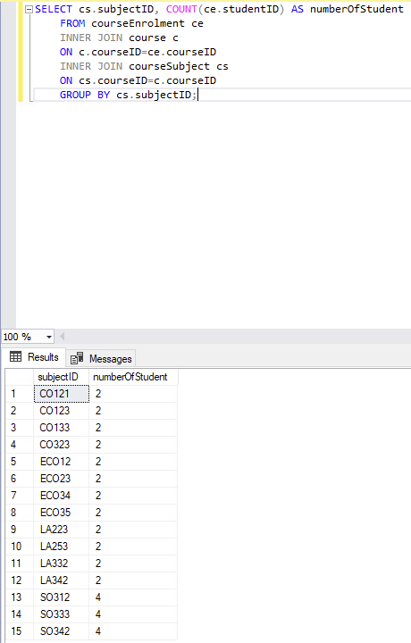

# 4. number of student in particular subject in a specific course

## it is limited to show the courseName in the result table because of the aggregate function showing number of student.

## Because of the limitation, the specific course which student enrolled can only be seen by the query

# subject = 'Italy' ; course = 'Language'

SELECT su.subjectName, COUNT(g.num) AS numberOfStudent

FROM (SELECT ce.studentID AS num, co.courseName, co.courseID

FROM courseEnrolment ce

INNER JOIN course co

ON co.courseID=ce.courseID AND co.courseName='Language') AS g, courseSubject cs, subject su

WHERE g.courseID=cs.courseID AND cs.subjectID=su.subjectID AND su.subjectName='Italy'

GROUP BY su.subjectName;

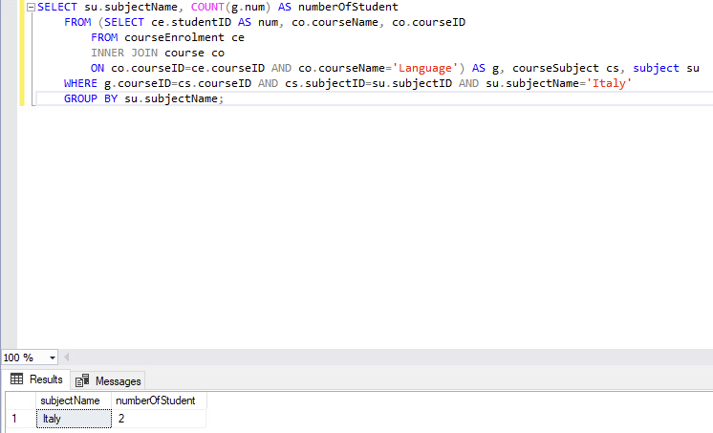

# 5. Tutor in particular subject

SELECT s.fullName, s.staffID, s.address, s.contactNo

FROM staff s

JOIN tutor t

ON s.tutorID = t.tutorID

JOIN class c

ON t.tutorID=c.tutorID AND c.subjectID='CO123';

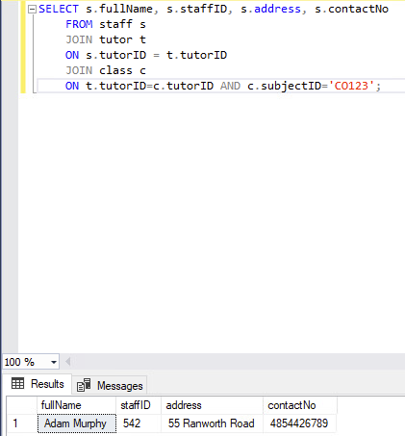

# 6. the average, minimum and maximum price of the units in a course (values and subject's name of each price)

## a. Average price in each course (in this case, the subjectName is not shown as it is an average price from all subjects in each course)

SELECT c.courseName, Avg(su.subjectPrice)

FROM course c

INNER JOIN courseSubject cs

ON c.courseID=cs.courseID

INNER JOIN subject su

ON cs.subjectID=su.subjectID

GROUP BY c.courseName;

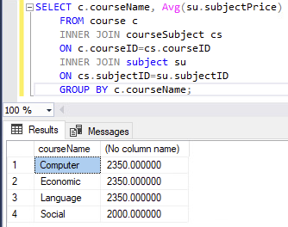

## Minimum price of unit in a course

### b. for course 'Social'

SELECT su.subjectName, Min(su.subjectPrice)

FROM courseSubject cs

INNER JOIN subject su

ON su.subjectID=cs.subjectID AND cs.courseID='U9910'

GROUP BY su.subjectName;

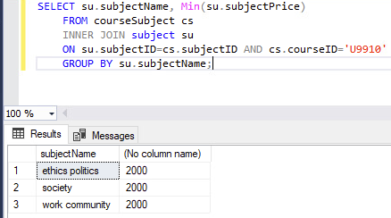

### c. for course 'Economic'

SELECT su.subjectName, Min(su.subjectPrice)

FROM courseSubject cs

INNER JOIN subject su

ON su.subjectID=cs.subjectID AND cs.courseID='U3919'

GROUP BY su.subjectName;

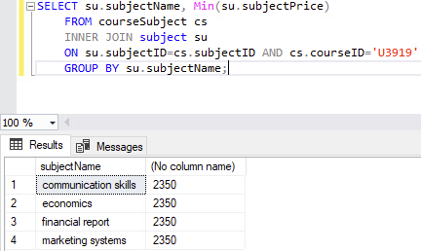

### d. for course 'Language'

SELECT su.subjectName, Min(su.subjectPrice)

FROM courseSubject cs

INNER JOIN subject su

ON su.subjectID=cs.subjectID AND cs.courseID='U5910'

GROUP BY su.subjectName;

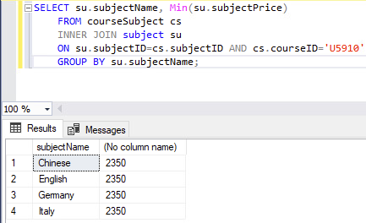

### e. for course 'Computer'

SELECT su.subjectName, Min(su.subjectPrice)

FROM courseSubject cs

INNER JOIN subject su

ON su.subjectID=cs.subjectID AND cs.courseID='U8020'

GROUP BY su.subjectName;

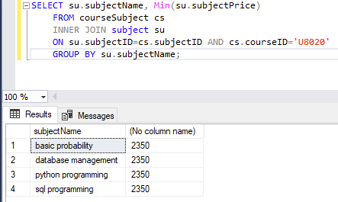

## Maximum price of unit in a course

### f. for course 'Social'

SELECT su.subjectName, Max(su.subjectPrice)

FROM courseSubject cs

INNER JOIN subject su

ON su.subjectID=cs.subjectID AND cs.courseID='U9910'

GROUP BY su.subjectName;

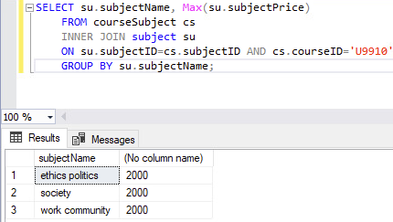

### g. for course 'Economic'

SELECT su.subjectName, Max(su.subjectPrice)

FROM courseSubject cs

INNER JOIN subject su

ON su.subjectID=cs.subjectID AND cs.courseID='U3919'

GROUP BY su.subjectName;

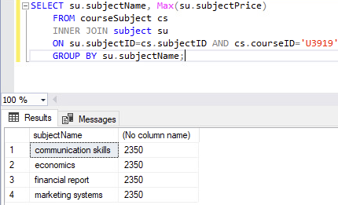

### h. for course 'Language'

SELECT su.subjectName, Max(su.subjectPrice)

FROM courseSubject cs

INNER JOIN subject su

ON su.subjectID=cs.subjectID AND cs.courseID='U5910'

GROUP BY su.subjectName;

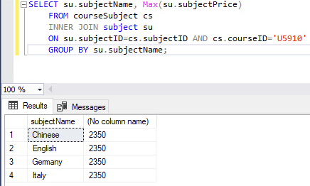

### i. for course 'Computer'

SELECT su.subjectName, Max(su.subjectPrice)

FROM courseSubject cs

INNER JOIN subject su

ON su.subjectID=cs.subjectID AND cs.courseID='U8020'

GROUP BY su.subjectName;

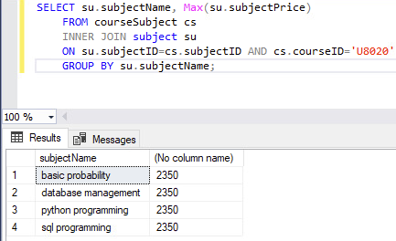

# 7. list name of tutors and their corresponding course and subjects in each course that they teach

SELECT h.fullName, co.courseName, h.subjectName

FROM (SELECT s.fullName, su.subjectName, su.subjectID

FROM staff s

INNER JOIN class cl

ON s.tutorID=cl.tutorID

INNER JOIN subject su

ON su.subjectID=cl.subjectID) as h

INNER JOIN courseSubject cs

ON h.subjectID=cs.subjectID

INNER JOIN course co

ON co.courseID=cs.courseID;

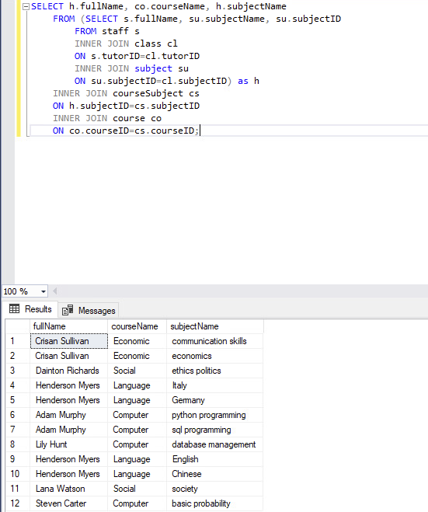

# 8. subjects and their scheduled time and date

SELECT j.subjectName, j.commenceDate, j.finishDate, sr.days, sr.startTime, sr.finishTime

FROM (SELECT su.subjectName, ct.timetableID, ct.commenceDate, ct.finishDate

FROM subject su

INNER JOIN class cl

ON su.subjectID=cl.subjectID

INNER JOIN classTimetable cl

ON ct.classID=cl.classID) AS j

INNER JOIN staffRoster sr

ON j.timetableID=sr.timetableID;

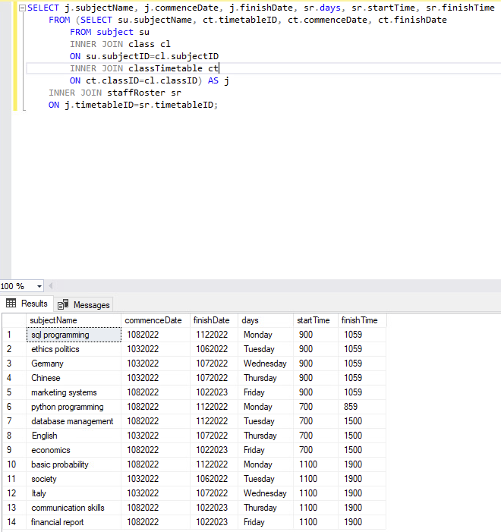

# 9. name of students who enrolled in a course (the result shows in all course)

SELECT s.fullName, co.courseName

FROM student s

INNER JOIN courseEnrolment ce

ON s.studentID=ce.studentID AND ce.isCompleted='yes'

INNER JOIN course co

ON ce.courseID=co.courseID;

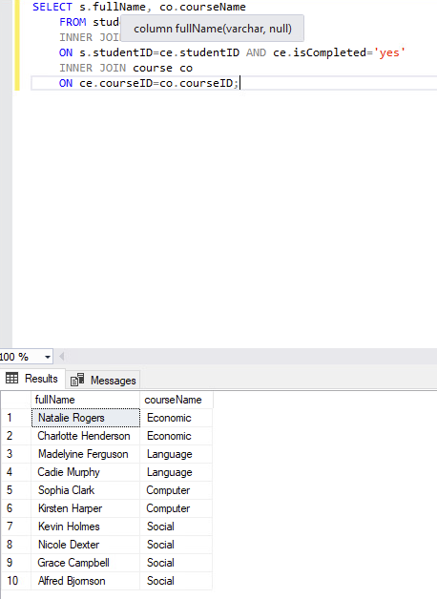

# 10. parent with their kids enrolled in a subject of a course

## in our case, all of the subjects are grouped into certain course, thus we directly access the subjectEnrolment instead of course.

SELECT DISTINCT p.fullName AS parentName, s.fullName AS studentName, su.isCompleted AS enrolledSubjects

FROM student s

INNER JOIN parent p

ON p.parentID=s.parentID

INNER JOIN subjectEnrolment su

ON s.studentID=su.studentID AND su.isCompleted='yes';

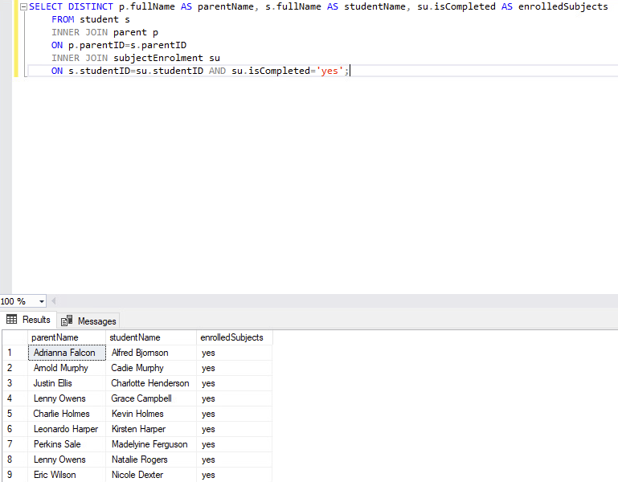

# 11. staff who works on Thursdays

SELECT st.fullName, st.contactNo, sr.days AS workOn

FROM staff st

INNER JOIN rosterTimetable rt

ON st.staffID=rt.staffID

INNER JOIN staffRoster sr

ON rt.timetableID=sr.timetableID AND sr.days='Thursday';

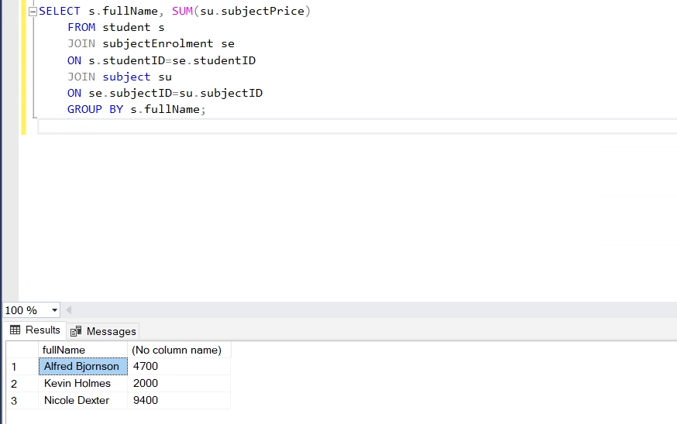

#### additional query to check administration staff details (supporting query no.11)

SELECT *

FROM staff

WHERE tutorID IS NULL AND managerID IS NULL;

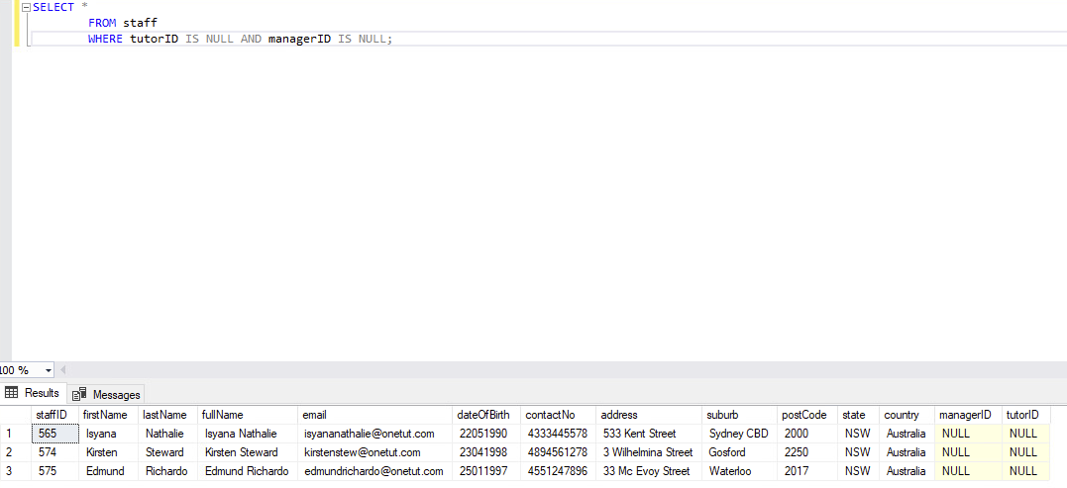

# 12. parents whose accounts are not verified by Bank

SELECT fullName, isBankAccVerified

FROM parent

WHERE isBankAccVerified='no';

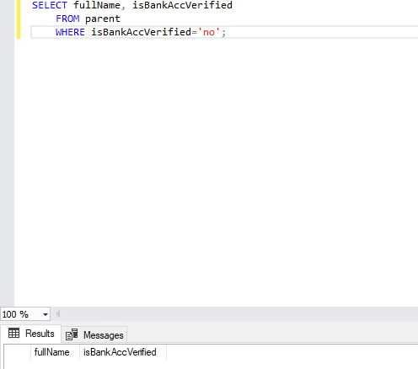

# 13. total payment per student

SELECT s.fullName, SUM(su.subjectPrice)

FROM student s

JOIN subjectEnrolment se

ON s.studentID = se.studentID

JOIN subject su

ON se.subjectID = su.subjectID

GROUP BY s.fullName;



